
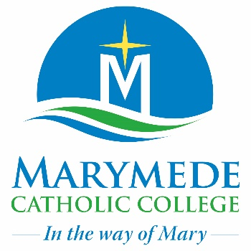
Acceptable Use of ICT Agreement for Students Years 9 -12

This Acceptable Use Agreement applies to students in Years 9-12 when using ICT.
Marymede Catholic College reserves the right to review any material in student accounts, file or cloud server space, to monitor appropriate use by students.

My responsibilities when using ICT
I understand that when I use school technology:
I understand that my digital actions have real-world consequences.
For my safety and the safety of other I agree that:
I will use appropriate language and engage respectfully in online discussions, emails, and messages.
I will not share sensitive details (e.g., full name, address, phone number) and will report any request for such information to a teacher or trusted adult at school.
I will evaluate sources for accuracy, bias, and reliability, and will report misinformation or harmful content to a teacher if necessary.
I will properly credit sources and acknowledge the use of AI-generated content where applicable. I understand that plagiarism, including using AI without disclosure, is a breach of school policy.
I will respect the legal and ethical guidelines of apps, software, and platforms I use within the school environment.
I will not access, modify, or delete files belonging to other students or staff without permission.
I will keep my passwords private and will not use another person’s login details.
If I feel unsafe online or witness harmful digital behaviour, I will reach out to a teacher or a trusted adult at school for support.
Unacceptable Behaviour when using ICT

For my safety, and the safety of others:
I will not use personal hotspots to bypass school filters and monitoring.
I will not record, share, or publish images, videos, or audio of others without explicit permission.
I will not use AI tools to alter images, videos, or voices of others without their consent or outside of a teacher-approved activity.
I will not use ‘peer to peer’ sharing (e.g. Airdropping on Apple devices) or other file-sharing tools to distribute files without approval.
I understand that phishing scams and malware can be embedded in emails, and I will avoid engaging with unknown senders.
I will only use school devices and digital platforms for academic purposes, unless otherwise permitted by my teacher.

Consequences for a breach of this agreement
If I break the rules of this Agreement my school will:
[Schools to develop their local approach to dealing with breaches making use of the Checklist for Suspected ICT breaches – students.]

As a student at Marymede Catholic College
My school also requires me to:
- Disable smart watch (if I possess one) features while I am at school
- Not make use of my mobile phone (if I possess one) during the school day
Schools may add any additional information to support their context]

Student Agreement
I have discussed this Agreement with my parents and agree to follow all of these rules.
[Schools may add information to support their context]
I understand that access to ICT is part of my learning. The inappropriate use of ICT goes against the Student Code of Conduct, which I have agreed to uphold, and consequences may apply for inappropriate use.
Student Name: _______________________________

Student Signature: ____________________________

Date: _______________________

Parent Agreement

- I agree that my child may use educational web tools such as Google Workspace for Education / MS 365 CoPilot as part of their schoolwork that uses off site servers.
- I understand that a list of additional Digital Tools used by students is available on request.
- I understand the school will provide adequate supervision and that steps have been taken to minimise risk of exposure to unsuitable material as per legislative requirements.

I have read and discussed the Acceptable Use of ICT Agreement with my child, and we understand the consequences for breaches of usage procedures.

Parent Name: _______________________________

Parent Signature: ____________________________

Date: ______________________

