

Staff and Child Safety
Marymede Catholic College

Being knowledgeable
- Annual College training
- Annual Mandatory Reporting Module
- Policies
  - All published on Marymede Way
  - MACS Code of Conduct
  - Child Safety Code of Conduct
  - Child Safety Policy
  - Child Safety and Wellbeing Procedures
  - Complaints Policy
  - College procedures

Our conduct
- Consistent with MACS Code of Conduct
- Consistent with Child Safe Code of Conduct
Being aware
- Warning
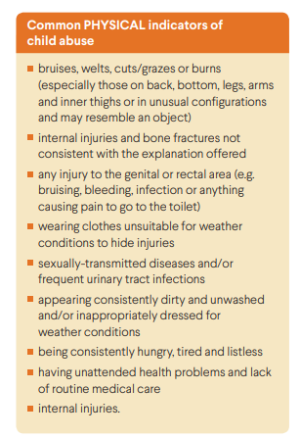
- signs of child abuse
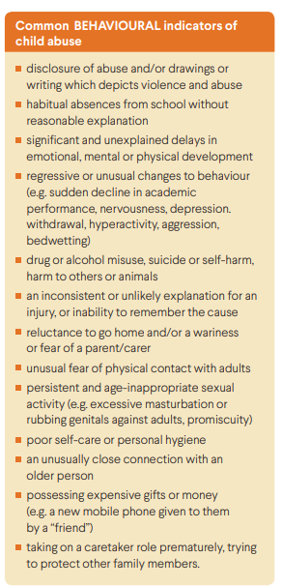
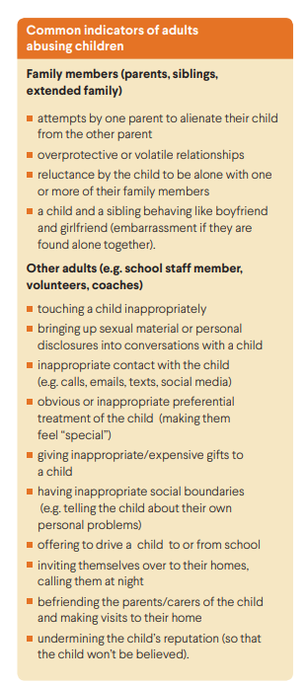

Reporting is you suspect a child is being abused
- Child abuse: Protect Protocol. Seek support from a College Child Safety Officer to make the appropriate report. Mandatory Reporting.

- Reportable conduct of staff: Report to Adrian Puckering, DP – Professional Culture or Tim Newcomb, Principal.

Information Sharing responsibilities
Staff can share information with each other if it is to advance the educational and wellbeing needs of a student with only lose those who need the information.

The Victorian Government introduced three inter-related reforms through legislation which aim to remove barriers to information sharing and enable services and organisations to work together more effectively to support the wellbeing and safety of children and reduce family violence. The terms 'wellbeing' and 'safety' have not been defined to allow for professional judgement.
These reforms are:
- the Child Information Sharing Scheme (CISS)
- the Family Violence Information Sharing Scheme (FVISS)
- the Family Violence Multi-Agency Risk Assessment and Management Framework (MARAM).
The CISS, FVISS and MARAM have expanded legal permissions for professionals to share and request information from other professionals. This ensures that professionals working with children can gain a more complete view of the children and young people they work with, making it easier to identify wellbeing or safety needs earlier, and to act on them sooner.
Schools and early childhood education services are required to respond to information sharing requests, and can make requests and proactively share information with other Information Sharing Entities (ISEs) under the CISS and FVISS.
This information sharing is also supported by Child Link. Child Link is a digital tool that displays information about a child to authorised key professionals who have responsibility for child wellbeing and safety in their school.
The schemes work in conjunction with existing information sharing legislative provisions. They do not affect reporting obligations created under other legislation, such as mandatory reporting obligations under the Children, Youth and Families Act 2005.

Action:
- If you wish to make a request to another service to share information or
- If you are quested to respond to information sharing requests
Please contact Lisa Murray, DP – Student Wellbeing who will assist you.

Record Keeping
Child Safety and Wellbeing records are any records that involve or relate to matters concerning child safety or which involves or relates to matters involving the safety or wellbeing of a child, which may include records relating to:
• concerns or complaints relating to child safety or the safety or wellbeing of a child
• safety incidents involving a child
• mandatory reporting
• reportable allegations
• reportable conduct
• other matters relating to child safety or the safety or wellbeing of a child.

Only authorised staff have authority to access, modify, use, release or dispose of records as appropriate.
All printed or hard copy Child Safety and Wellbeing Records will be securely stored in locations that are locked, and which are only able to be accessed by authorised staff – Principal’s office. Hard copy records must contain the date of when they were created

All digital / electronic Child Safety and Wellbeing Records will be securely stored in such a way as to prevent unauthorised access.
- Student incidents and conversations etc: SIMON Notes
- Mandatory Reporting: Teams, Child Safety Officers
- Reportable Conduct: Teams, DP – Professional Culture

It is essential to:
• document work activities including decisions made, actions taken and notes of meetings and important conversations
• ensure records include relevant contextual information e.g. the date and location of a meeting and who was involved
• make sure records are complete, accurate and can be understood in the future
• keep records in authorised systems and designated storage areas
• protect records from unauthorised access and disclosure.

Staff must not:
• destroy, delete or alter Child Safety and Wellbeing records without authorisation
• damage or lose Child Safety and Wellbeing records in their care
• keep Child Safety and Wellbeing records on personal devices or personal cloud storage locations or in portable storage devices such as USBs or
• remove Child Safety and Wellbeing records from school premises without authorisation.

Complaints Policy
Forward all complaints to principal@marymede.vic.edu.au

